INTRODUCTION TO NODE.JS

What is Node.js?
Node.js is open-source and cross-platform runtime environment for Javascript. Node runs V8 engine of google chrome outside of the browser.
Node runs in single process for every request doesnot run multi threading.
Node enables asynchronous programming for its libraries and function in non-blocking manner, meaning it will continue the process after the response comes back rather than staying idle or blocking the thread.
This allows the single server to handle multiple concurrent requests.

Difference between Node.js and browser
Node.js | Browser
Does not have such global vairables but provides api to handle file, os, etc | Provides global variables like window, document, etc
Node use both CommonJs and ES6 | Follows only ES module system because of ES6 specifications
Easily upgrades, adjust to new version | Cannot update, adjust to new version need modules like Babel

Node Package Manager
npm is a standard package manager for Node.js. It enables us to install, update and manage dependencies for our project. Dependencies are pre-built, third-party pieces of code that helps to run our project.
In Node.js, every .js file is a module, so npm acts as a central repository for managed packages or libraries. There are over 2.1 million packages in npm registry.
Yarn and pnpm are alternatives to npm cli.

Packages
‘ npm install ‘ helps to install all the depedency in “package.json”. All the dependencies are installed in “node_modules/” folder. “package.json” is a important file the helps to configure the modules, dependencies, commands for our project.
Npm install <package_name> lets us install package. ‘npm i <package_name>’ short hand for install.
We have flags such as:
- --save-dev shorthand -D installs and adds the entry to the package.json file devDependencies
- --no-save installs but does not add the entry to the package.json file dependencies
- --save-optional shorthand -O installs and adds the entry to the package.json file optionalDependencies
- --no-optional will prevent optional dependencies from being installed

BASICS OF NODE JS

Installing Node
If you have a package manager on your system, you can use that. For my Fedora Linux system:
sudo dnf5 in -y nodejs

Hello World Program
To run a simple "Hello, world!" program in Node.js first create a file named helloworld.js and add the following code:
console.log("Hello, world!");
Then open a terminal, navigate (cd) to the directory where helloworld.js is located, and execute:
node helloworld.js
If everything is set up correctly, you'll see the text "Hello, world!" printed in the terminal.

Using Modules
Node allows us to use code into different small reusable modoules using CommonJS standard. It means we can import javascript files as modules. We can import files using require()by using just it or storing in a variable or using maps. There are 3 different types of node modules we can import.

Requiring built-in modules
Use the require() function to include built-in modules like url. For example:
var {parse} = require("url");
var parsedURL = parse("http://example.com?name=John");
console.log(parsedURL.host); // "example.com"

Requiring Third Party modules
Use npm to install third-party modules. For example:
npm install mustache --save
Include the installed module in your code:
var Mustache = require("mustache");
console.log(Mustache.render("Hi, {{name}}!", {name: "John"}));
// "Hi, John!"

Requiring your own module
Define and export a function or variable
// random-integer.jsfunction
randomInteger();
{
return Math.floor(Math.random() * 100);
}
module.exports = randomInteger;

Import and use it in another file:
var randomInt = require("./random-integer");
console.log(randomInt()); // Random number between 0 and 100

package.json
Use npm init to create a package.json file to manage dependencies and project metadata.

Node: an asynchronous world
The asynchronous nature of Node.js is comparable to multitasking in real life. For instance, while waiting for muffins to bake in the oven, you can jog but not actively prepare more batter or read a book at the same time. Node works similarly: while an external resource (like a hard disk or network) is working on a task, Node can handle other tasks without waiting for the first one to finish. However, Node never performs multiple tasks simultaneously; instead, it relies on asynchronous processes to utilize external resources efficiently.
const {readFile, writeFile, appendFile} = require("fs");
exampleFilePath = "./NodeJs/Modules/content/example.txt";
console.log("Start 1");
readFile(exampleFilePath, "utf-8", (err, result) => {
if (err) {
console.log(err);
return;
}
console.log();
console.log("Done with task 1");
});
console.log("Start 2");
something = "This will write a new line by either creating a new file or overwriting existing one. Here overwriting is done";

writeFile(exampleFilePath, something, (err, result) => {
if (err) {
console.log(err);
return;
}
console.log();
console.log("Done with task 2");
});

console.log("Start 3");
appending = "This will append at end of the line";
appendFile(exampleFilePath, something, (err, result) => {
if (err) {
console.log(err);
return;
}
console.log();
console.log("Done with task 3");
});

Output:
Start 1
Start 2
Start 3
Done with task 2
Done with task 3
Done with task 1

Building a web server with Node: the http module
Node’s http module is the foundation for creating web servers. Here’s how it works:
- Require the http Module:
Import the built-in http module:
var http = require("http");
- Define a Request Handler:
Create a function to handle incoming requests and send responses:
function requestHandler(request, response) {
console.log("Request to: " + request.url);
response.end("Hello, world!");
}
- Create and Start the Server:
Use http.createServer() to create a server and start it on a specific port:
var server = http.createServer(requestHandler);
server.listen(3000); // Server listens on port 3000
- Test Your Server:
Save the file as myserver.js and run it using node myserver.js.
Visit http://localhost:3000 in your browser to see "Hello, world!"
- Handle Different URLs:
Customize responses based on the request URL:
function requestHandler(req, res) {
if (req.url === "/") {
res.end("Welcome to the homepage!");
} else if (req.url === "/about") {
res.end("Welcome to the about page!");
} else {
res.end("Error! File not found.");
}
}
This approach is great for simple servers, but for complex applications, using a framework like Express helps organize code and simplifies server management.

Summary
- There are a number of ways to install Node. I recommend using a version manager so that you can easily change versions and upgrade as needed.
- Node’s module system makes use of a global function called require and a global object called module.exports. The two make for a straightforward module system.
- You can use npm to install third-party packages from the npm registry.
- Node.js has evented I/O. This means that when an event happens (such as an incoming web request), a function (or set of functions) is called.
- Node has a built-in module called http. It is useful for building web applications.

WHAT IS EXPRESS?

Functionality of Node.js
Node.js helps to run javascript in server side. It is used mainly to create servers for web applications. When creating a web application by Node.js, we write a single javascript function which serves as a core of our application. Hence, this is complex to write .
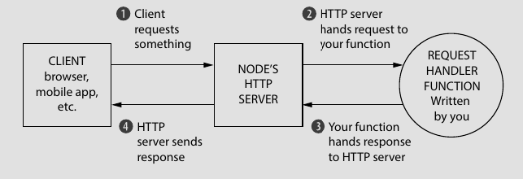
Figure 3.1: The flow of a request in Node.js web application
The figure explains that Node.js HTTP server facilitates process like managing the low-level network communication with clients and delegating requests to your request handler function. The request handler function listens to client’s incoming request, examines it and sends a response appropriately. Response send by server may be an HTML file or JSON object or HTTP status code.

What express adds to Node.js?
Express add two big features on top of Node.js HTTP server:
- It adds abstraction layer to a lot of complexity by providing number of helpful functions or conveniences. Example: Sending a single JPEG file in raw Node.js requires extensive, performance-optimized code (~45 lines). In Express, this is reduced to a one-line sendFile method.
- It augments Node.js's capabilities with utilities like easier parsing of request URLs, direct access to the client's IP address, simplified response methods
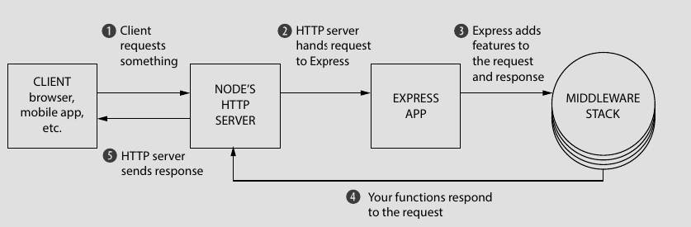
Figure 3.1 : The Flow of a request through Express
The flow of a request in an Express application (as show in figure 1.2) involves several layers of modular functionality:
- The client (browser or mobile app) sends a request.
- The Node.js HTTP server receives the request and hands it to Express.
- Express processes the request through a middleware stack:
- Middleware functions handle logging, parsing, or other general tasks.
- Specific route handlers respond to requests for particular URLs or endpoints.
- Once processed, the response is sent back to the client.
This layered, modular approach improves flexibility and readability compared to a single large request handler.

What is Express?
Express is a small web framework that runs on top of Node.js. It helps to simplify the Node.js’s web API functionality and add other features. It helps to organize web application through routing and middlewares.

The core parts of Express
Express smooths out a lot of the difficult parts and says “Don’t worry; you don’t need to deal with this ugly part. I’ll handle this!” In other words, it’s magic!
At a high level, Express provides four major features:

Middleware
Middleware can handle tasks from logging requests to sending static files to setting HTTP headers. In contrast to vanilla Node, where our requests flow through only one function, Express has a middleware stack, which is effectively an array of functions that handles request.

Routing
Routing is a lot like middleware, but the functions are called only when you visit a specific URL with a specific HTTP method. Routing is a way to map requests to specific handlers depending on their URL and HTTP verb. For example, you could only run a request handler when the browser visits yourwebsite.com/about.

Sub-applications
Express application can be divided into many sub-applications. For example: handling API can be a sub application while rendering HTML file can be another sub application. These sub-applications help Express to organize more efficiently. In Express, we also call these sub-applications as routers. These routers helps to extend Request and Response objects with different methods as per application requirements.

Views
Views allow you to dynamically render HTML. This both allows you to change the HTML on the fly and to write the HTML in other languages. A number of different view engines are available. There’s EJS (which stands for Embedded JavaScript), Handlebars, Pug, and more. All of these have one thing in common: at the end of the day, they spit out HTML.
Example: Setting up views with HTML
var express = require("express");
var path = require("path");
var app = express();
app.set("views", path.resolve(__dirname, "views"));
app.set("view engine", "ejs");
The above lines tells express that our views will be in a folder called views and that we are going to use the EJS templating engine.

The Obligatory Hello World Program
var express = require("express");
var app = express();
app.get("/", function (request, response) {
response.send("Hello, world!");
});
app.listen(3000, function () {
console.log("Express app started on port 3000.");
});

ROUTING

What is Routing?
Routing is the process where a web server maps of HTTP verbs and URIs to specific methods that generates response to the cients request. A basic example is if we’re using a browser to visit example.com/olivia, here’s what the first part of the raw HTTP request might look like:
GET /olivia http/1.1
That HTTP request has a verb (GET), a URI (/olivia), and the HTTP version (1.1).
The server maps the /olivia URI to specific route’s controller. The controller then generates a response by calling the method. In simple terms, routing is mapping of methods, according to URIs and HTTP methods.
Example:
app.get("/olivia", function (request, response) {
response.send("Welcome to Olivia’s homepage!");
});
The function matches the user request in browser. If the request is anything else than this then it will be ignored. It will produce response in www.<website_you_created>/olivia

Routing in Express
Express gives flexibility to define routes from different places, unlike Django where routes needs to be defined on a single files (urls.py).

Grabbing routing parameters as variables
The simplest way to pass variables as in route parameters is putting a colon in front of it. We will get the value in params property of the request ‘request.params’. Eg:
app.get("/users/:userid", function (req, res) {
let userId = parseInt(req.params.userid, 10);
// other code…
});

Using regular expression to match routes...

Grabbing query arguments
The query arguments are passed in url after ‘?’. Ex: Google.com/search?q=nepal&nt=sick
app.get(“/search”, function(req, res){
let searchStr = req.query.q;
let otherQuery = req.query.nt;
//...other codes continue
});

Splitting routes
We can write whole route in app.js but by convention we write routes in ‘routes/’ folder and name file as ‘userRoute’ for ‘/user/’ URI.
Splitting of routes help to manage our code more efficiently. We can create two versions of api, handled differently. The below example shows how we split routes in express for two different versions of api
# app.js
var express = require("express");

var apiVersion1 = require("./api1.js");
var apiVersion2 = require("./api2.js");

var app = express();

app.use("/v1", apiVersion1); // route for /v1/timezone or /v1/all_timezones are handled
app.use("/v2", apiVersion2); // route for /v2/timezone is handled

app.listen(3000, function() {
console.log("App started on port 3000");
});

# routes/api1.js
var express = require("express");
var api = express.Router();

api.get("/timezone", function (req, res) {
res.send("Sample response for /timezone");
});
api.get("/all_timezones", function (req, res) {
res.send("Sample response for /all_timezones");
});
module.exports = api;

# routes/api2.js
var express = require("express");
var api = express.Router();
api.get("/timezone", function (req, res) {
res.send("API 2: super cool new response for /timezone");
});
module.exports = api;

Summary
- Routing is a mapping of an HTTP verb (like GET or POST) and a URI (like /users/123).
- Routing can map to a simple string. It can also match against patterns or regular expressions. Express has the ability to parse query strings.
- Routers can be used to split your application into many smaller applications, which is useful for code organization.
- You can use Express with HTTPS by starting the server with your certificates.

MIDDLEWARE
Middleware refers to different functions/packages that helps to handle requests in sequence. It is similar to request handler in Node.js except request handler has one large handler to manage everything, middleware allows many to happen in sequence.

Middleware and middleware stack
The Node runtime parses the request from the client, creates into two JS objects ‘request’ and ‘response’. Express helps these objects pass through array of function which we call middleware stack. Every middleware function needs to be ended either by calling next() or res.end(). The next() transfers the flow of program to next middleware in the stack. The res.end() ends the response handling and again Node runtime bundles the response into bytes and sends it to user.
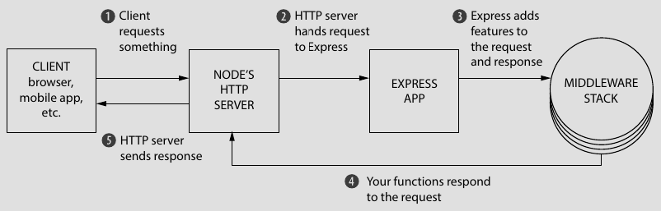
Figure 5.1 Flow of request and response in Express
The middleware function in Express primarily takes 3 arguments: request, response and next as shown in figure 5.3. As discussed above, request and response objects represents the HTTP request and response. The ‘next’ is a function that passes request and response to next middleware in the stack.
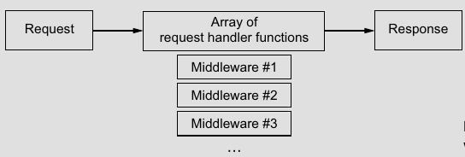
Figure 5.2 A request in middleware

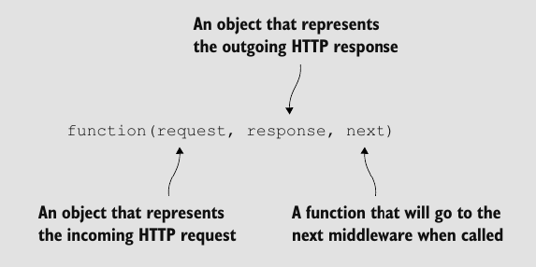
Figure 5.3 : Middleware function with 3 arguments

Note:
If we don’t use next( ) or res.end( ) the request will stuck endlessly as it is not resolved. res.end( ) is a must at the end, we can use similar function such as res.send( ) or res.sendFile( ) that calles res.end( ) internally.
Function that sends response(res) is called controller. We cannot use 2 res.end as it gives error so we use ‘return’ keyword before it.

Static server middleware
The static middleware serves the static files such as images, css, javascript files, etc. Express has in-built static middleware i.e. express.static( ) function.
const publicDir = path.resolve(__dirname, ‘pubilc’);
app.use(express.static(publicDir));
The static middleware shares every files of <project_directory>/public/ folder as publicDir is the path of the pubic folder inside project folder. Here, the express setups public directory when the server is running. After each request to access public files, the server searches the public directory if not found then transfers (uses next() ) it to 404 middleware as it won’t throw any error.

404 handler middleware
The 404 middleware handles the request that does not find the any other request, meaning it handles routes that does not exist. When user tries to access resource that does not exist, 404-handler returns custom message specifying the resource not existing.
Example:
app.use((req, res, next) => {
res.status(404).json({error: "Not Found", message: "The requested resource could not be found."});
});
The 404-handler middleware is kept at the last piece of middleware of the express application. It acts as fallback of request for unmatched routes.

Error-handling middleware
Error handler middlewares handles the error thrown by the express app. When regular middleware throws an error, all other consecutive middleware are ignored and passed to the error-handling middleware function. The error-handling middleware, unlike regular middleware, takes 4 arguments: error, request, response and next. We basically write error handling methods and like any other middleware, we end it with res.end( ) or next( ).
app.use(async (err, req, res, next)=>{
if(err){
return res.status(500).send(`Internal server error ${err}`)
}
next();
});
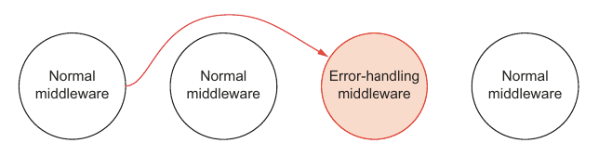
Figure 5.4: Triggering of error-handling middleware

Other useful middlewares
Body-parser, Helmet, Cookie-parser, compressions

Summary
- Express gives us features that helps to handle request and generate response through multiple array of function called middleware stack.
- Each function has 3 arguments ‘request’, ‘response’ and ‘next’ where request, response are object but next is a function that transfers handling to next middleware.
- Error handling middleware has 4 arguments ‘error’, ‘request’, ‘response’ and ‘next’ which catches error thrown by regular middlewares.
- Every middleware function needs to be ended either with next() except for last middleware that needs to be ended with res.end( ).
- Other functions such as res.send( ), res.sendFile( ), res.json() calls res.end( ) internally.

BUILDING APIs

HTTP Verbs (HTTP Methods)
Htttp verbs are the type of methods that client sends request to the server along with requests. Example:
GET /olivia http/1.1
There are generally 4 types of methods:
- GET: GET method sends client read only data. It is an idempotent method.
- POST: POST method, creates a new record. It is not for updating methods. It is used also for adding things in cart, list etc.
- PUT / PATCH: PUT or PATCH updates existing records but PUT creates a new record if the updating record doesn’t exist. They are idempotent since change in a record is always same regardless the number of times it is done.
- DELETE: DELETE method obviously deletes the existing data as it refers. It is also idempotent as deleting a record always deletes the same record not the other.
Idempotent means that the method will not change the data differently however many times it is called.
These specifications are not mandatory but a standard.

API versioning
API versioning is helpful to mitigate the problem of updating version of the API used. It helps to other to consume the API without the problem of completely stripping them of API usage.
Example: /v1/timezone
Express can help to do API versioning efficiently by making this kind of separation easy with the help of routers.

Summary

MYSQL2 IN NODE JS

Connecting database
We need to import ‘mysql2’ or ‘mysql2/promise’. The Promise version creates an asynchronous connection with database. We can use its function asynchronously too.
To connect Database we can use either createPool or createConnection
createConnect creates a single connection to MySQL database. It is used for simple oneoff queries.
createPool handles multiple connection to MySQL database that can be reused for multiple queries concurrently. So we will be using createPool();
// connect.js
const { createPool } = require('mysql2/promise');

const pool = createPool({
host: 'localhost',
user: `root`,
password: `1234`,
database: 'express_tut',
connectionLimit: 10,
queueLimit: 0,
});

Testing connection
We use the getConnection( ) method of pool object, that retrieves connection with database to handle queries. We also need to use release() method (of returned getConnection object) that transfers the connection back to pool.
const testConnection = async function () {
try {
const connection = await pool.getConnection(); // This function checks connection
console.log('✅ Database connected!');
connection.release(); // This important to release connection from database back to pool
return true;

} catch (error) {
console.error('❌ Database connection error::', error.message);
return false;
}
}

// if we call testConnection it checks connection with database.
testConnection();
Note: We keep this file as db.js in ‘project_folder/config/’

CRUD operations
In ‘models/’ folder we created asynchronous functions that handles crud operations in database. Since we are not using an orm, We already created a table called ‘Tasks’ in ‘express_tut’ database of MySQL.
const { pool } = require('../config/db');// importing pool.

const getAllTaskDB = async () => {
let sqlQuery = 'SELECT * FROM Tasks;'
try {
let [result] = await pool.execute(sqlQuery);
return result;
} catch (err) {
console.log('getAllTaskDB err:', err);
throw err;
}
}

const getTaskDB = async (task_id) => {
let sqlQuery = 'SELECT * FROM Tasks WHERE id = ?'
try {
let result = await pool.execute(sqlQuery, [task_id]);

return (result[0].length > 0) ? result[0] : null;

} catch (err) {
console.error('getTaskDB err:', err);
throw err;
}
};

const createTaskDB = async (name, completed) => {
let sqlQuery = 'INSERT INTO Tasks(name, completed) VALUES (?,?)'
try {
let result = await pool.execute(sqlQuery, [name, completed]);
return result;
} catch (err) {
console.log('createTaskDB err: ', err);
throw err;
}
};

const updateTaskDB = async (id, name, completed) => {
let sqlQuery = 'UPDATE Tasks SET name=?, completed=? WHERE id = ?'
try {
let sqlQueryResult = await pool.execute(sqlQuery, [name, completed, id])
let result = await getTaskDB(id);
return (sqlQueryResult[0].affectedRows > 0) ? result : null;
}
catch (err) {
console.log('udpdateTaskDB err:', err);
throw err;
}
};

const deleteTaskDB = async (id) => {
let sqlQuery = 'DELETE FROM Tasks WHERE id=?';
try {

let deletedTask = await getTaskDB(id);
let sqlQueryResult = await pool.execute(sqlQuery, [id]);

return (sqlQueryResult[0].affectedRows > 0) ? deletedTask : null;

} catch (err) {
console.log('deleteTaskDB err: ', err);
throw err;
}
The variable functions do the expected query.
Here we used pool.execute(sqlquery) method instead of pool.query(sqlquery). The main difference between execute() and query() is that execute method prepares the statement first meaning, it uses parameterized input. This helps prevent SQL injection because the parameters are automatically escaped. The prepared statement can be cached and reused, which may improve performance if you execute the same query multiple times with different parameters. query() exceutes without preparing the statement efficient for static queries but cannot be cached or reused.

Summary
- We use ‘mysql2’ or ‘mysql2/promise’ packages.
- pool = createPool({...}) creates pool of concurrent connection with database. It is used to handle multiple queries.
- connection = pool.getConnection() retireves connection with database. And connection.release() will release the connection and gives back to pool.
- pool.query() executes sql query statically, it doesnot provide any parameter binding.
- pool.execute() prepares sql first, query can be cached and reused better for security and performance.

JWT
JWT stands for JSON Web Token. It is an open standard that is used for securely transmitting information between parties as a JSON object. Typically used for authentication and authorization, a JWT consists of three parts:
- Header: Header consists for the information about the token. It specifies token type (jwt) and signing algorithm.
- Payload: Payload contains the main data that is transmitted.
- Signature: Signature is created by taking encoded header and payload signing with a secret key. It ensures the data is not tampered.

JWT in Express
We use package ‘jsonwebtoken’ methods such as sign( ) to create a new token, verify( ) to verify the token.

Signing JWT
Signing JWT means creating a new token. It is done my sign( ) method of ‘jsonwebtoken’ package. The method takes 3 arguments: Payload data, secret key and other options like expiry time. Example:
const jwt = require("jsonwebtoken");
const SECRET_KEY = "Nepal";
const generateAccessToken = function (userEmail) {
return jwt.sign({user_email: userEmail}, SECRET_KEY, {expiresIn: "2h"});
};

Verifying JWT
We can verify a JWT token by verify( ) method of ‘jsonwebtoken’ package. It takes 2 required arguments: Token string and secret key. Example:
const verified = jwt.verify(token, SECRET_KEY);
It works synchronouly. It returns the decoded payload data that has been signed to the user or else throws error it couldn’t verify the token.
The method can also uses callback function but it will work asynchronously. The callback function uses 2 arguments.
const verified = await jwt.verify(token, "Nepal", (err, decoded) => {
if (err)
console.log(“jwt error:”,err);
console.log(“payload”:decoded);
}
);
Note: The asynchronous verify( ) method is not promise-based so we dont need to used ‘await’ keyword. So, its better to use synchronous verify( ).

JWT Usage
We use 2 token strategy for jwt usage one is access token and another is refresh token. These tokens helps in managing user authentication for API requests.
- Access Token: It is used for authentication API requests and access protected resources. It typically contains the necessary user information and permissions (claims) needed to authorize a request. They are short lived. User sends it in each api request to access authenticate itself.
- Refresh Token : It is used for generating access token, if token is expired or lost without requiring for re-authenticate the user. It is long live and stored in http-cookie with secure enabled. We store the refresh token in database which helps us to create more secured server.

Summary
- JWT is used for securely transmitting data across the network by encoding the data with a secret key.
- We use “ require(‘jsonwebtoken’) ” for jwt in express.
- jwt.sign( {payload}, SECRET_KEY, {options}) is used to create a new token.
- jwt.verify( ‘token-string’, SECRET_KEY, options/callback) checks the token for its authenticity.
- verify( ) works synchronously for 2 arguments, but if we use 3 arguments where a callback function handles error and decoded token, it works asynchronously (not promise based).
- We use access token authenticate user for each request but refresh token regenerates access token if the access token it lost or expired.

USEFUL LINKS
- ExpressJS API documentation
- Regular Expression Javascript | MDN
- EJS Documentation

